

**School of Computer Science Engineering and Information Systems**

**WINTER SEMESTER 2024-2025**

**PMCA601P – FULL STACK WEB DEVELOPMENT LAB**

**Slot: L49+L50 & L2+L4**

**Faculty Name(s): Prof.K.Sumangali**

Cycle Sheet - Based on HTML, CSS, JQUEY,AJAX

Q1.

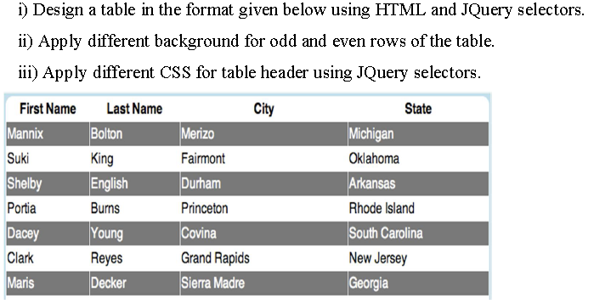

Q2. **Assume that the external site named "http://date.jsontest.com/" contains**

**the following JSON data: { "date": "10-03-2024", milliseconds_since_epoch":**

**1727931665031, "time": "05:03:40 AM" }**

**Implement appropriate AJAX script to access the above site and display the**

**data as per the format given below:**

**Date:10-10-2024 Time:05:03:40 AM**

Q3. 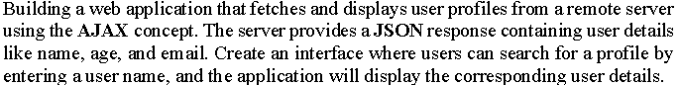

Q4.

